**Lab 1**

**(Sequence)**

**Q1\ Square area**

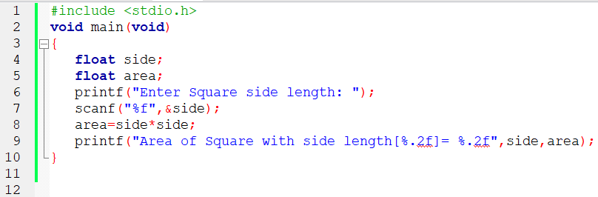

**Run**



**Q3\ Circle area**

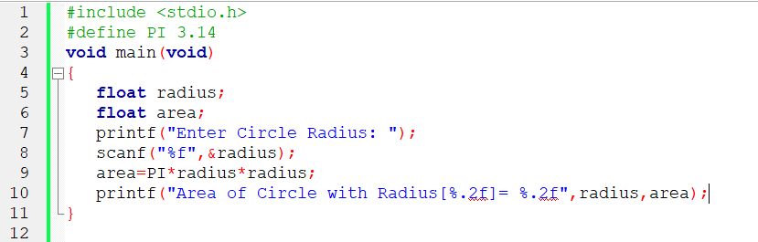

**Run**



**Q8\ Fewest number of coins (1,5,10,25,50)**

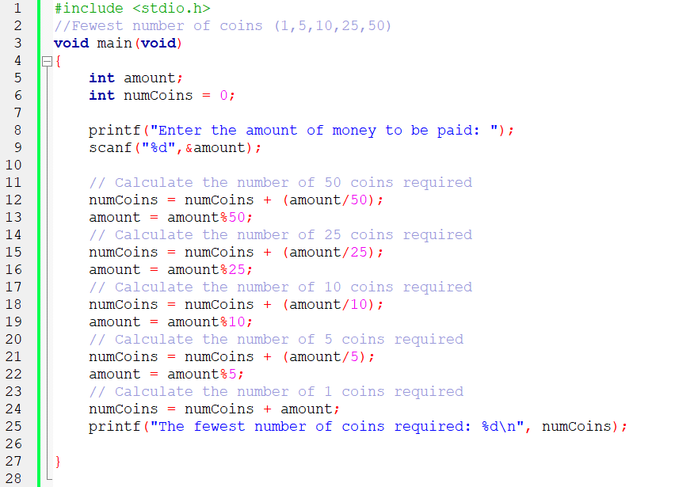

**Run (141 = 50+50+25+10+5+1 total 6 coins)**

